ECA5802-IOE AND AI DRIVEN SYSTEM
EXPERIMENT 5(a): SIMULATION AND PERFORMANCE EVALUATION OF NFID/NFC BASED DEVICE IDENTIFICATION AND IOE DATA INTEGRATION USING NODE –RED,MQTT

OBJECTIVES:
- To simulate NFC-based device identification for IoE applications.
- To identify devices and verify their unique identification details.
- To transmit device data using MQTT communication in Node-RED.
- To integrate and visualize device information on a dashboard for real-time monitoring.
SOFTWARE REQUIRED:
Node-js,Node RED,Escllipe Mosquitto

PROGRAM CODE:
let ids = [
"RFID001",
"RFID002",
"NFC003",
"RFID004",
"UNKNOWN999"
];

let n = (flow.get("scanNumber") || 0) + 1;
flow.set("scanNumber", n);

let tag = ids[(n - 1) % ids.length];

msg.topic = "ioe/device/scan";

msg.payload = {
tag_id: tag,
device_id: "DEV-" + tag,
timestamp: Date.now(),
temperature: Number(
(25 + Math.random() * 10).toFixed(2)
),
status: "scan"
};

return msg;
Reader

let data = msg.payload;

if (typeof data === "string") {
try {
data = JSON.parse(data);
} catch (e) {
return null;
}
}

if (!data || !data.tag_id || !data.timestamp) {
return null;
}

let allowed = [
"RFID001",
"RFID002",
"NFC003",
"RFID004"
];

let valid = allowed.includes(data.tag_id);

let received = (flow.get("receivedCount") || 0) + 1;
flow.set("receivedCount", received);

let validCount = flow.get("validCount") || 0;
let invalidCount = flow.get("invalidCount") || 0;

if (valid) {
validCount++;
flow.set("validCount", validCount);
} else {
invalidCount++;
flow.set("invalidCount", invalidCount);
}

let latency = Math.max(0, Date.now() - data.timestamp);

let sum = (flow.get("latencySum") || 0) + latency;
flow.set("latencySum", sum);

let start = flow.get("testStart");
if (!start) {
start = Date.now();
flow.set("testStart", start);
}

let elapsed = Math.max((Date.now() - start) / 1000, 0.001);

msg.payload = {
tag_id: data.tag_id,
device_id: data.device_id,
identified: valid,
temperature: data.temperature,
latency_ms: latency,
received_count: received,
valid_count: validCount,
invalid_count: invalidCount,
throughput_msg_per_sec: Number(
(received / elapsed).toFixed(2)
),
avg_latency_ms: Number(
(sum / received).toFixed(2)
)
};

return msg;

OUTPUT:
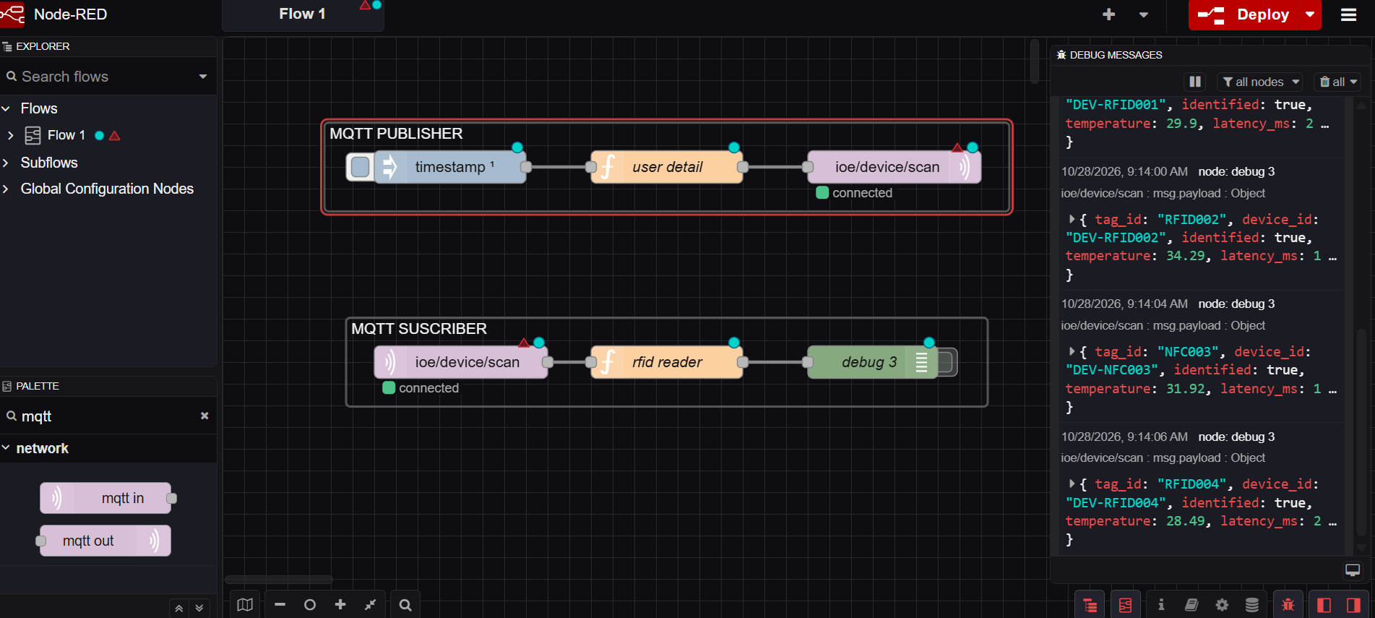

RESULT:
NFC-based device identification and IoE data integration were simulated successfully using Node-RED and MQTT. Device information was transmitted, received, and displayed on the dashboard, demonstrating effective communication between IoE layers.

